http://mulley.ie/blog/2009/01/giving-away-our-online-marketing-documentation/

Online Marketing by Damien Mulley
Feel free to print, burn, hack and reuse any of the content in this for commercial and non-commercial uses but it would be nice if you referenced Mulley Communications when reusing.

Introduction

Marketing has changed.
Traditional advertising does not work, brochure-like websites do not work, the web has given people ultimate freedom of choice and of goods. When there are no monopolies and constrictions, interrupting people's lives is not effective marketing anymore.

There are no secrets. The networked market knows more than companies do about their own products. And whether the news is good or bad, they tell everyone. – Cluetrain Manifesto

“If the news is important, it will find me” – some random mySpace user

An online marketer now needs to find where people are congregating online and needs to engage them in a meaningful way. Be it in matching with what they are looking for, watching how they interact and understand what they’d like or listening to their natural opinions on your company or market and reacting to that.

Google
Google is the most used search engine and is used more each day. Google's share of the search market is growing, not declining. Each month Google is used by more and more people in the English speaking world and many are jumping shop from Yahoo! and Live.com to start using Google. People who already use Google start using it more frequently too. It is almost addictive.

Search engines themselves are changing. They are being used for more and more things. Website owners and bloggers find they are using Google to search their own properties as it is so effective. People are using Google as a spellchecker, as a calculator and as a unit converter. People search Google for the latest news. Google is the jumping point for web destinations but also as a Swiss army knife for non web actions such as spelling, as mentioned above.

Many Irish people instead of typing in Bebo.com in the address bar actually go to Google and search for Bebo and then click on the result to bring them to the site. Consider the amount of trust Google now has for people to do this.

It makes sense then to try and engage with people on Google since that's where they start so many of their digital actions. It’s a trusted place for them. You can react to someone’s searches by making sure your website ranks well in search results (SEO) but since you cannot rank well for every single search result, you can reach these people by advertising next to search results with relevant ads (Adwords)

Onsite Techniques
Search Engines and Your Website

SEO
One definition: Search Engine Optimisation is the process of streamlining the structure and content of a website to make it position well in search engine results.

Originally search engines were quite basic and you could do well for search phrases based just on the keywords that were on your website, nowadays with Google dominating, the ranking methodologies are far more complex and Google state there are about 200 factors that are considered by their search engine before you are given a placing in the results.

Some of these factors have more weight than others. Adjusting your website to take consideration of just one of these can create a positive outcome for your site in search placings. Combining all of them could mean that your website could jump from 60th place to 4th place or even 1st. It does all depend though on your competition and what they're doing to make sure they do well in Google too. As SEO becomes more popular, ranking sites does too but clever planning from the start will result in good placings.

Some factors to keep in mind:

Page Titles
The title of a page is the writing at the very top of a web browser. Google sees this almost like the title of a book. The more descriptive the title the better for Google results. Consider a book called "Dante's Inferno", it might be hard to decipher what the rest of the book contains; now compare this to "101 recipes using beef". One is far far more descriptive than the other.

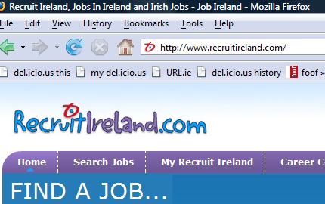

Google puts weight into the title of a page and will point to the title when giving search results.
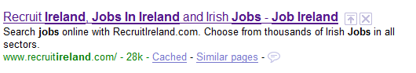

If your front page has a title of "Murphy's" then Google can't decipher much. If you have "Murphy's Crystal Goblet manufacturers" then they get more information. How many people will search for a company name in Google compared to a description of what they're looking for? This applies to every single page on your website, not just the front page.

The Title of each page can be changed in the source code of the page. This is what it would look like:
<title>Gastronom.ie - Food and Drink in Ireland</title>

Meta Description
A page's description meta tag gives Google and other search engines a summary of what the page is about. Whereas a page's title may be a few words or a phrase, a page's description meta tag might be a sentence or two or a short paragraph. Description meta tags are important because Google might use them as snippets for your pages. Adding description meta tags to each of your pages is always a good practice in case Google cannot find a good selection of text to use in the snippet.

Like the Title attribute, you can change or add a description to your page in the source code. This is what it would look like:
<meta name="description" content="Gastronom.ie is your single source for all things Irish Food and Drink. Containing delicious recipes, restaurant reviews, world cuisine and all types of comparisons of wine, beer and everything else." />

Body of the page
The body of each page on your website will be examined by Google too. It will compare the content here to the title of the page. If they match/suit each other then it will consider that the page and content are well structured.

Headers
Headers on a page are also important, treat them almost like chapters or section titles in a book. If you can be descriptive of the content of the trailing paragraphs, it's good for readers and it's also good for Google

Links
Google excels at automating processes and removing as many humans as possible from the mix, yet if it wasn't for humans, Google wouldn't have done so well. Google changed search forever when it stated that a site or webpage that gets a lot of links should get more attention from them and rank better. A link can be seen as a vote for a page. The more links, the more it probably should be seen as valuable/worthy. Websites that get a lot of links do well in search results. On closer inspection it is more in-depth in that though.

Volume of links
The number of links is good. Most links are good. More links, if Google trusts them is good for your site and lifts the boat in a way. However, if the links are more focused with their text and come from very trusted sites, your site can do better again.

Linking text
The text in a link pointing to your website or webpage is very very important. Your website can actually do well for search results for certain keywords even if they are not in your page title or in the body of your page. This can be done by other websites linking to you with keywords in the text of the link. This is why the Irish Communications Regulator (ComReg) ranks first in Google for "telecoms poodle" or why George Bush was number 1 for months for the phrase "miserable failure"

Link weight
In addition, a well ranking website will boost you more than websites that don't rank as well. A blog that nobody links to might not impact your search rankings if they link to you but if Trinity College (for example) links to your site then you might get a boost that's enough to push you up a place or two in search rankings.

Age of website
The older your website, the more Google will see it as having some weight or credentials. With the ease of registering and uploading a website, a website can appear online within minutes of a news event happening with keywords about that news event. Sites like these spring up in order to act like traps for people who will visit and will be directed to click on sneaky ads and make the site money. Google realises this and so does not give as much weight (and many times no weight at all) to new websites. Your new domain could very well end up in the Google "sandbox" for weeks or months until Google begins to trust it. If your site gets links from credible websites, the time in the sandbox can shorten quite a lot.

Freshness
Google lives and thrives on content and especially likes new content. If you update your website on a regular basis, Google will come and visit you on a more regular basis. Google is now apparently visiting sites every few minutes and content from some sites will appear in search results within 15 minutes of the content being created. Keeping your website updated and fresh will get rewarded by Google but in addition it will get rewarded by people who will also come back to you.

Google.ie/Google local
You may have noticed (In Ireland) that you are redirected to Google.ie when you go to Google.com. Google wants people to use the local version of their search engines as they see local content as being of more value to people in that geographic location. A lot of what people search for can be addressed by local websites and local businesses. To make it more valuable, Google guesses as to the Irishness of a website. If you have a .ie domain name like Mulley.ie then Google says you are probably Irish. In addition if the machine/web server where your website resides is owned by a known Irish entity then Google says you or your site are probably Irish too. What Google does then is reward you in Google.ie search listings. You get an extra nudge in the local versions of Google. You are not punished though in the Google.com listings.

You can also tell Google you are Irish or even part of your site is Irish using the Google Webmaster tools which you install/integrate with your website. That way, Irish sites who have special Spanish or German sections of their websites can do well in Google.ie for most of their site and do well for the Spanish section in Google.es and well for the German section in Google.de We don’t go into Google Webmaster Tools here as that’s an entire document in itself.

There is no secret to rank well but...
Google themselves tell you that writing good and engaging content without using dodgy shortcuts is what will get you traffic from them and they're correct. In addition, links, the currency of the web are given out by people, You can write content that is loved by Google and it being a machine might not spot it's gibberish but a human will and may not link to it and may not visit it. A site that doesn't get links and visits might alert Google to it being not so valuable, despite appearing to the machine as being well structured and written. Of course Google is probably not far off being able to spot human readable content...

A guide to print off and read is Google’s own SEO guide available here:

http://www.google.com/webmasters/docs/search-engine-optimization-starter-guide.pdf

These are the basics, if you are already doing this and want to improve more it would be worth talking to an SEO expert.

Blogging

Free blog services: www.blogs.ie www.wordpress.com

www.IrishBlogs.ie is where you can see what bloggers are saying

Why Blog?
1. Search engine audiences
2. Getting recognition as an expert
3. Improves your message
4. Free R+D
5. Feedback on your space which you can guide

Blogging tips:
Pick a niche, become the authority
Network – IrishBlogs.ie
Put your blog on existing website
Host the website in Ireland
Regular posts – 1 per week for a year
Examples: BubbleBrothers.com IceCreamIreland.com

There is a companion Business Blogging document that comes with this document and provides much more information on this subject area.

Offsite Techniques:

Social Bookmarking
Social Bookmarking is bookmarking items in public. You share with people what you are bookmarking and people can subscribe to what you bookmark. Your bookmarks are stored online, not on your computer.

“Jill is an interesting person so I want to see what she bookmarks”

For Example: Delicious.com

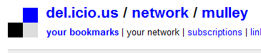

You can see how many subscribe and who get updated when I save a bookmark on Delicious:

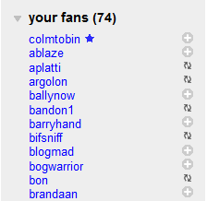

Social Bookmarking sites are: Digg.com, Reddit.com, StumbleUpon.com

Digg allows people to vote on your bookmark. The American Idol of social bookmarking.

Adding Social Bookmark buttons to your blog posts and pages allow people to easily share their bookmarks. Instead of 1 person reading your page and that’s it, if they bookmark it now, 30 or 100 or 1000 people might see the page.

Online advertising:
Search advertising

Google Adwords
Google allows you to interact with searchers with their Adword system.

Google’s own guide to their Ad system is required reading for all those who want to advertise effectively. It’s advised to read this and the below summary: http://www.google.com/adwords/insider/Insiders_Guide_to_AdWords.pdf

For some really good insights from an Irish company see this blog post http://www.redflymarketing.com/blog/10-ways-to-increase-your-adwords-quality-score-a-mini-case-study/ and all blog posts in this category from RedFly: http://www.redflymarketing.com/blog/category/ppc-marketing/

You will see Adwords on the top and side of Google search result pages. Google however expect the ads to be relevant to what people are searching for, the same way search results are as relevant as they can be. Your ads will show up in search result pages only if what people are searching for correlate to keywords you have chosen.

On top of that you cannot actually bid for first or second place, instead, like webpages, Google will decide where you ad should place based on the way people value your ad. The more they click, the higher it will place. This encourages people to write ads that users see as being valuable. This sometimes makes it difficult for some traditionalists to write these ads where over-the-top promises won't get clicks but to-the-point messages instead win the day.

There are now professional copywriters out there who specialise in Google Ads.

A company should not be looking to run ads that are based on their company name unless the name is very generic. Why would you pay money for ads based on your company name when you should be ranking well or first on Google for your company details?

Adwords Auction System
Choose keywords, bid for them with maximum price you'll spend, see the results

Tools to use for choosing keywords

Google will show you roughly the volume of searches for the keywords you choose and the average price that is paid for these keywords. This allows you to budget for ads if you want to go with those words/phrases.

Specialised landing pages
It makes sense to have pages created especially for ad traffic. That way you can measure the impact of the ads and see what people do on your website once they've reached you. Additionally, landing pages should be all about the sale and that specific product. Give the people doing the searches what they want, based on their search. Uncluttered landing pages end up with better sales than noisy ones with lots of opportunities to click away and get distracted.

Rarely should you have ads that just bring people to your frontpage unless that page contains the best data about your product. For any company that has more than one service or product, there should be pages for each ad.

Also landing pages that have been optimised for the Google Ad in terms of copy will see the click rate at a lower price. Google rewards a landing page that is in synch with the Google Ad. Again, meaningful ads bringing people to meaningful websites means Google has happier repeat customers.

Geotargeting Ads
Google allows you to target your ad to people (based on their computer address) so you can target Irish people or UK people or even break it down by their county. If you just target Irish people you can both save money (as the market for Irish attention is not as competitive) but also you might be able to rely on brand recognition in the local market.

Google Content Network
Google opened up their ad system so their ads can be shown on other pages and sites apart from search results pages. Taking the same technology as the contextual ads on search results, you can target ads to show up on websites owned by Google like Blogger.com and Blogspot.com or owned by other people. The ads that are served are based on the keywords that Google finds as it searches all the pages. Since a website or webpage can contain so many disparate phrases, sometimes the ads don't fit well with the actual content of the webpage. As a result clickthrough rates for ads here are not as high as on Google search results.

Timing of ads
Ads can now be timed to go out at different times of the day. The benefit of this? Ads could be based around certain events during the day, perhaps you want to make sure those you target are businesses and if your ads only run during business hours then it avoids a little more people that are not using Google for business purposes. If you have a limited daily budget, pushing your ads out during certain hours may be of benefit or perhaps you are advertising daily deals which expire by 2pm etc.

Google Trends
Google Trends www.google.com/trends allows you to see volumes of search words and phrases people are carrying out using Google and this can be broken down geographically from worldwide to Ireland, to even local counties. Given the way that computer addresses are allocated by Irish Internet providers, the breakdown by city or county is often wrong with people from Cork being shown as being from Waterford or Dublin, depending on where their connection to the Internet has been routed. Google Trends allows you to compare terms and their volumes too so you can ride the wave of popular search terms or find ones with a little less volume but the cost of showing ads next to them might be considerably cheaper.

Google Trends for Websites
Google Tends for websites http://trends.google.com/websites also gives you a rough estimate on how popular websites are and you can compare most websites to each other and break it down by Geographic location. This is a handy way of seeing how popular you are compared to your competitors or what other sites get visited by the audience that visit your site and those other sites.

Google Adplanner
Google Adplanner – www.Google.com/adplanner is another tool from Google that gives you rough traffic statistics and demographic data for most online websites apart from the sites that Google own.

A worthwhile aspect of this tool is that you can submit a website to it and the Adplanner will give you back other websites that are visited by the same people. This is important if you are only targeting specific demographics and want to reach as many of them as possible. Adplanner will show you all the other sites that are in that same bracket. In addition if a site you'd like to target does not take ads, you can still target other sites that do take ads and have a crossover audience.

Many times Adplanner will probably introduce you to other websites you may never have known about because of their niche but who might be of extreme value to you.

Social Networks:

Bebo
The most searched for term on search engines? Bebo. The most used website in Ireland apart from Google and other search engines? Bebo. The average Bebo user spends 23 minutes a day on that website. There are over a million Irish Bebo profiles. Consider that there are less than a million Irish people on broadband in Ireland. Over 100% penetration rate.

While seen as a place where young people congregate, many over the age of 18 are on Bebo too. Many have said they joined because their friends were on it and only joined because they were missing out on what their peers were doing. Being seen as a place for kids, a messy place, full of noise and yet those saying that still join the service is a testament to the drawing power of Bebo.

You can engage with people on Bebo through various means. You can create a profile for your brand/company/product and stick it up there and hope people will connect with it and see what you're up to. You can create a "Skin" for your product and share it with everyone. But for your profile and skin you are competing with millions of others and 100s of 10000s of skins. You can enlist Bebo however to promote both so that your profile can be a highlighted profile and your skin can be a highlighted skin. This does not come cheap.

A recent example of this is the Pat the Baker profile and Skin. The profile now has 1000s of friends, has "whacky" competitions getting people to sing the theme and submit photos of themselves with Pat the Baker sliced pans. The look of the profile changes frequently which someone probably considered was a way of keeping people's attention. It won't.

Why Pat the Baker thought Bebo was a way of getting more people to buy sliced pans is a mystery. Brand recognition? Kids don't buy sliced pans and in the world of pester power they probably use their quota to have other items bought.

LinkedIn:
LinkedIn is a business focused social network where you can upload the equivalent of your CV and share it with others. One of the features of LinkedIn is that you can send a message to 10 contacts at a time or send it in the form of a question to everyone at once and they in turn can forward that on to everyone else.

While it might harp back to email chain letters, the profile of LinkedIn means that it is very possible to reach a good deal of potential ProductX buyers via CompanyA staff and their supporters sending a message to all their contacts asking to spread the word about ProductX.

Facebook:
Facebook has gone from 7000 Irish users in January 2007 to 400,000 Irish users in January 2009. Facebook started off as a network for college kids and the core look of the site is of a very clean interface which focuses more on information that the look. Most profiles on Facebook look almost the same with the only places on the profile where people can express themselves is on the Wall and in various applications that people can add. There are 150 Million users of Facebook worldwide.

Creating a Facebook Page

Facebook encourages companies not to create a Facebook profile for their brand, product or company but instead to create a Facebook Page which will give a company more control than a profile and can assign ownership of it to multiple people. If you create a Facebook Profile for your company or brand it will get nuked by them quickly enough and with it all the work you put into it. Register yourself on Facebook using a Profile, register your company with a Facebook Page.

One of the advantages a Facebook page has over a normal profile is that you can get statistics on usage of the page. In addition you are able to send a message to everyone that is a “Fan” of the page without everyone being able to reply all. Something a profile does not offer.

Creating a Facebook Page is very easy. Simply to go the Facebook Page section of Facebook and choose Create Page or else use this direct link: http://www.facebook.com/pages/create.php

This will bring you to the creation page. Choose what area of business you want your page listed under or click Brand or the Artist option. Here we want to create a Fan Page for the Grapefruit Moon Café:

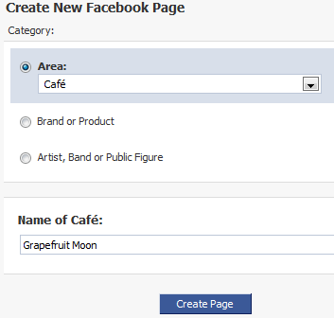

Once you fill in the options, the page is now created but is not yet published. You can not add details to the page such as text, photos and videos.

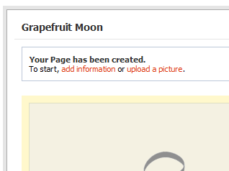

You can change ownership of the Page and add more admins. You can become a fan too if you want.

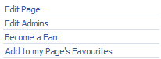

A very handy option is that if you have a blog, using the Notes option, you can add a blog feed:

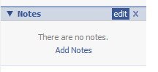

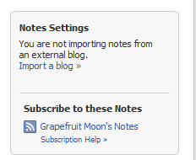

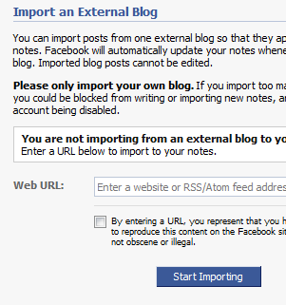

The blog contents will be imported as you update the blog, meaning you can bring in external content to feed your page.

How to advertise on Facebook
So you want to run ads on Facebook for your business, whatever that business is? Thanks to Social Ads from Facebook you can target 400,000 people in Ireland that currently use the service in the same way that Google’s Ad system allowed you to target ads but even better than Google you can almost be sniper-like on how you target the ads. You can target by age, gender, work status, relationship status, college education and interests.
In this walkthrough, let’s pretend to advertise to UCD folks. All you need is a credit card and to spend a minimum of five dollars on your ad campaign.
1. You need to decide what your ad is going to be. We’re going to advertise jobs in McDonald’s to those in UCD.
2. So first go to Facebook.com/ads
3. Click on the big green button!
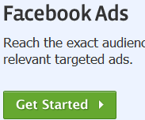
4. Choose what website address you want to be clicked. Here it’s the job page on www.McDonalds.ie
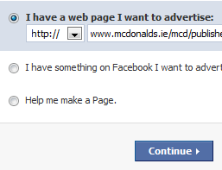
5. From here choose your audience. We picked 18-25 year olds that attend UCD.
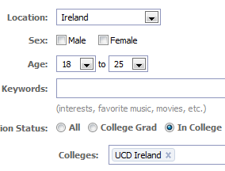
6. It said there were circa 1380 people from UCD on Facebook:
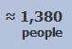
7. Then write your ad and you can also include an image. The McDonald’s logo was chosen.
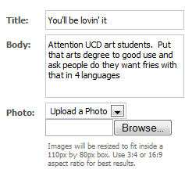
8. You can also see a preview of what the ad will look like:

9a. After this you can choose how much is to be spent and what times the ad will be shown. You can also pay per click or by views:
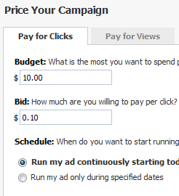
9b. If you choose pay per views you have the option of also displaying the ad in the News Feed of people, something which will probably get you a lot more clicks and views since people actively scan and read their News Feed.
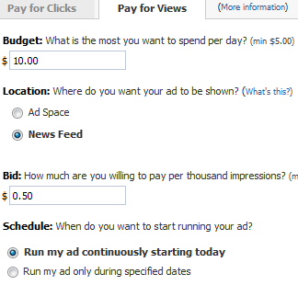
10. Finally, review the campaign and pay up and off you go.
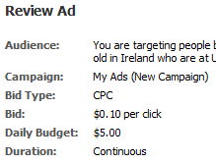
Remember though that just because you can advertise and target specific people does not mean that you will get a lot of click throughs. You have to work hard on writing good copy and using good images to get the attention of a Facebook public that doesn’t seem to pay too much attention to ads. A Facebook user is different to a Google searcher is different to someone that responds to TV or newspaper ads.

Measuring Facebook Campaigns

Check your website stats:
While Facebook is a walled garden and you can’t see inside it without logging in, they still send a lot of traffic out to websites. If you have set up a Facebook Profile, a Page, a Group or run Facebook “Social Ads” then they can all send users from Facebook to you. In addition so can anyone else in Twitter if they’re talking about you. For a marketing campaign you should have special website addresses tailored for the campaign so you know only your campaign elements are sending that traffic to your site. Google Analytics or any of the clones will allow you to measure incoming traffic from Facebook and you can tell if they are coming from profiles, ads, pages or groups.

Facebook Lexicon
Facebook Lexicon allows you to see what Facebook users have been discussing. It’s a keyword trend program that doesn’t show the number of times a keyword is mentioned but the number of people who mentioned the keyword one or more times over a certain period of time. More details on Facebook Lexicon here. For companies you can get an estimate of the number of times your brand or product is mentioned. Ideal to see are there jumps around the time you start a campaign. You can also compare up to five different keywords at the same time. But there’s a big but, it doesn’t give raw numbers so it’s just a rough estimate but it’s still good. Maybe you can purchase them from them though? Big marketing companies would probably pay for that.
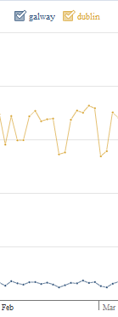

Facebook Pages
I recently created a Facebook “Page”. The Page was called “Gnéas” as a joke. When you become a fan, your friends also see you’ve become a fan of it as it shows up in their news feed. So a few people saw “Damien is a fan of Gnéas” and the viral element would have encouraged others to join too. The stats that are provided to Page owners are fairly good.
This is the Insights Control Panel (Everyone calls the stats pages Insights these days):
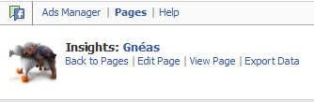
This is a graph of sign-up activity:
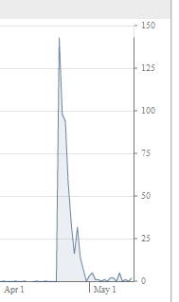
Some demographics of the Fans:
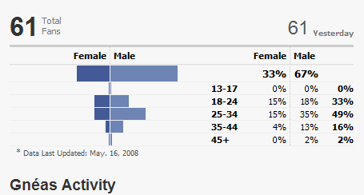

Facebook Social Ads
Read this Blog Post on how to run Social Ads. Like Pages there’s a whole section on statistics for your ads.
This is the Ads control panel. Note that the ads for the Gnéas page got canned because the Facebook prudes deemed the ads inappropriate:
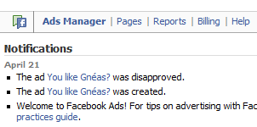
Here’s how you can export all your data to Excel and add more calculations:
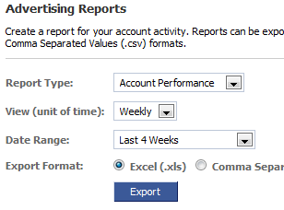

Facebook Apps
Many marketing campaigns will include the creation of special applications to get people to learn more about your brand/product. If you have an application created, Facebook will give you a whole load of information about installations and usage. Who, what, where, when etc. Data once again can be exported and presented to you.
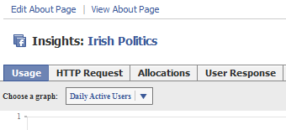

Messy Measuring - Facebook Groups
Facebook Groups can be created by anyone and some do well and some stagnate. It takes a lot of work to keep activity going and Facebook really prefers if you use Facebook Pages to do marketing. They supply nice stat tools as mentioned above for Facebook Pages but nothing at all for Groups unless you pay a considerable sum for a sponsored Group. But you can manually check your group and measure it. Measuring it is a case of seeing how many have signed up for the Group and what the activity is like. So for example, the Bertie, Take Enda With You group:
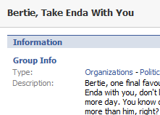
You can see how many members there are. Then you can see what kind of activity is happening by counting the number of discussions, photos and videos that have started/ were added.
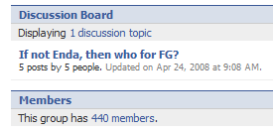
And you can also look at the Wall activity.
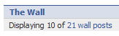
Other measurements to take into account are the number of people that respond to messages that you send to the whole Group. See what the response rate is like. Don’t be surprised if it’s very very low.

YouTube:

Measuring your Internet Marketing campaign on YouTube
YouTube now has “Insights” for your videos. They supply some fantastic stats now that shows you how many viewed the video, where they came from, how they came to find it, their gender and age groups etc. With all these details you can give se exactly how effective you were and even amend live campaigns due to the data.
Here are some stats on my David Lynch on an iPhone video, 20k views and YouTube breaks it down for me which is great:
The four tabs for stats:
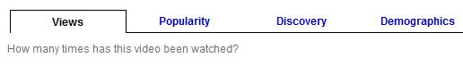
Stats the public can also see:
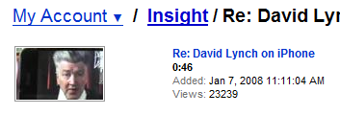
Graph goodness:
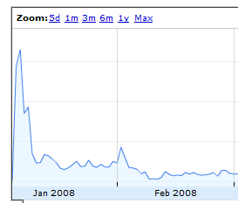
There’s a lot more stats too so log in and have a look. The Google Blog gives more details about YouTube Insights. This is a good Washington Post article on how marketing companies use it too.

Actively Listening:

Listening and community relations:
Online marketing is more than just broadcasting and interacting on your blog or website or forum. With new tools and the two-way and multi-way conversations that technology has brought, more and more companies are monitoring the web for mentions of their name and products and are then interacting with potential customers where their name is mentioned. Mostly this is happening on blog and discussion forums.

I would recommend, subject to resources, to use Google Alerts and Technorati Alerts to run continuous searches for “CompanyA” and “ProductX” so it can be gauged what the level of discourse online is for the competition but as well as that if a blogger or website owner is asking questions or needs clarification, the answer can be brought to them. This could convert many that are sitting on the fence about products.

Who’s saying what about you?
http://www.google.com/alerts

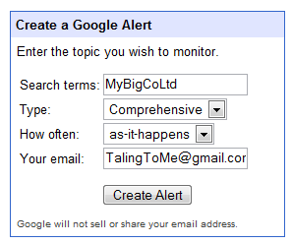

Google alerts allowing you to run constant searches on your name, your company name and anything else you want searches for. When a new website or webpage comes online and mentions these keywords, their details are emailed to you. If you use a tool like Google Reader, iGoogle or Bloglines you can subscribe to an RSS(news feed) of these results.

Listening on Twitter
Twitter is the latest “social network” type service with about 2 Million very very active users. Twitter is like Facebook with everything except the status update removed. With Twitter you can update a set of people who “follow” or subscribe to your messages in 140 character bursts. You can also subscribe to other people on this network and they do not need to give you permission to do so. You could follow 10 people on Twitter and have 1000 followers.

Twitter can be used as a snapshot of the most active users of the online population and is a great way of seeing what the zeitgeist that minute, hour, day or week is. Using the search facility on Twitter at: http://search.twitter.com you can run searches for your company name or product name or your competitor, business area etc.

This video from Niall Harbison gives a real world example: http://www.niallh.com/increase-sales-twitter/

This blog post from Peter Tanham shows you how to listen and engage only to people that are near you (based on their profile details): http://petertanham.com/2009/01/finger-on-the-pulse/

Listening on discussion forums
Like Twitter, you can listen/read and monitor online chatter about your, your business, your products and your competitors on thousands of discussion forums worldwide. A service called BoardTracker - http://www.boardtracker.com/ allows you to search a lot but not all these forums at once.

Unlike Twitter, interacting with what people are saying is much more difficult and sometimes impossible. The rules for each forum will vary and you will have to adhere to each one. Even if you cannot interact directly, you might be able to target ads to that discussion forum using Google Adwords.

Miscellaneous:

Website Statistics

www.statcounter.com

For monitoring who is coming to your site, to what pages and what search terms they are using, a website statistics software package is needed. Irish website StatCounter.com does it all for you and all you need to do is install a small piece of your code on

Finding Royalty Free Images Online

Jazzbiscuit
http://www.jazzbiscuit.com/blogCCsearch/
Copy and paste code on to your blog or website after searching for images that you want

URL.ie
Shorten very long web addresses into much shorter ones with www.URL.ie
Ideal for emails when addresses get split over two or more lines

Copywhat Mulley Communications Ltd. 2009

