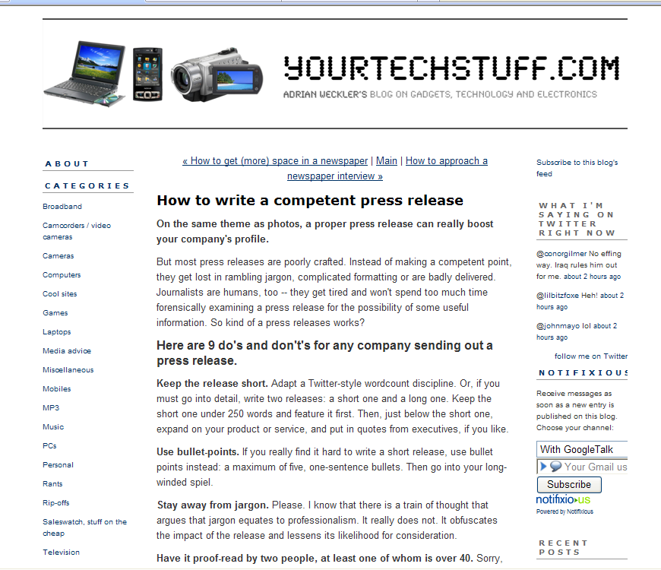

How to write a competent press release
On the same theme as photos, a proper press release can really boost your company's profile.
But most press releases are poorly crafted. Instead of making a competent point, they get lost in rambling jargon, complicated formatting or are badly delivered. Journalists are humans, too -- they get tired and won't spend too much time forensically examining a press release for the possibility of some useful information. So kind of a press releases works?
Here are 9 do's and don't's for any company sending out a press release.
Keep the release short. Adapt a Twitter-style wordcount discipline. Or, if you must go into detail, write two releases: a short one and a long one. Keep the short one under 250 words and feature it first. Then, just below the short one, expand on your product or service, and put in quotes from executives, if you like.
Use bullet-points. If you really find it hard to write a short release, use bullet points instead: a maximum of five, one-sentence bullets. Then go into your long-winded spiel.
Stay away from jargon. Please. I know that there is a train of thought that argues that jargon equates to professionalism. It really does not. It obfuscates the impact of the release and lessens its likelihood for consideration.
Have it proof-read by two people, at least one of whom is over 40. Sorry, young ‘uns, but too many of you cannot spell. Or, at least, you cannot tell the difference between your and you’re. Or between its and it’s. Or between products and product’s. But we, as journalistic recipients, can: and it doesn’t look great. Note that mis-spellings are not the end of the world: society has moved into a general disregard for grammar and punctuation.
If the press release is about a product, include an image. Make sure that it is (a) low-res and (b) a jpeg. (If there is interest, you’ll be asked for a high-res version of the image.) Don’t be worried about sending such an attachment: the days of journalists having mailbox limits for images are generally gone. Anything up to 2MB is usually alright. Do not, please, attach PDFs -- they are a pain in the neck. And never use a PDF as an image format.
Do not attach the press release as a Microsoft Word attachment. Some companies do this because they think it looks better with all the italics and accents and other inconsequential crap. Ignore this approach -- word attachments are as likely to remain unopened. Just write the press release in the e-mail, for God’s sake.
Include the basic information that a journalist would need to further the story or to write something short without further contact. This means, especially, the price. It is astounding how many PR people send out releases on new products and services -- often mass-market ones -- without mentioning the price. It is the absolute first question that will be asked. And journalists resent having to waste time calling or e-mail back to get a detail that should have been there in the first place.
Don’t style your press release as a teaser. You may think: ‘I’ll put just some of the information in -- that way, they’ll ring and I’ll get them into a conversation so they’ll be more likely to write a bigger piece’. Wrong -- they just won’t ring. (Unless it’s a reeeallly slow day.)
Don’t try and be clever with e-mail. One company I know puts a future time-stamp on their e-mail press release so that it sits at the top of the e-mail basked for 24 hours. Such gimmicks are very irritating and convey an image of desperation.
January 20, 2009 in Media advice | Permalink

Comments
Don't spammers use that technique of forging the time stamp on an email? I can't believe someone would do that and think it was a good idea - most of the time the email will get intercepted by a filter and get dumped in a junk folder.
Posted by: Orlaith | January 20, 2009 at 02:08 PM
More great tips Adrian. This backs up alot of what Damien says in his Media Course. I have only done one press release so far, and DID get some coverage with it so was v pleased. Will remember all of these hints in the future also.
Posted by: Ciara Crossan | January 21, 2009 at 09:49 AM
Nice post. You wouldn't believe how many press releases I regularly trash because of embarrassing spelling errors. My advice would be, unless you're absolutely sure of your abilities, to leave the release writing to the professionals.
Posted by: The Sexy Pedestrian | January 21, 2009 at 01:31 PM
I'd add a tenth (as a former PR person):
Put a two-bullet summary of the "news" at the top of the release. Neither of the bullets should have more than six words (watch as Adrian pulls out press releases from me with fifteen words per bullet...)
Posted by: Keith | January 21, 2009 at 02:46 PM
Some great points there Adrian and I'd agree with all of them but can I just add an extra from the journalist point of view?
If you are sending out a press release make sure that people are available for follow-up calls from journalists.
It continues to amaze me how many times I try to find out extra information or to get a quote from someone only to be told that the PR person and/or the chief executive or whoever it is I need to talk too is away that day/week.
Being told that Mr/Ms X will be back in five days time is downright infuriating so
If you are sending out a release of any kind make sure the relevant people are all a phone call/e-mail away...or be prepared to have your press release (and future ones) ignored.
Posted by: Charlie | January 21, 2009 at 08:47 PM
I have a question about the first point. Are you saying it is OK to send two releases together as one document? That's an interesting idea I haven't thought of before.
Also, is there any benefit to using something like Flickr to make photos available to the press? Or is that just over complicated?
Posted by: Elle | January 27, 2009 at 07:17 PM
Hi Elle,
1. Yes, don't worry about breaking convention. As long as the first part is short, snappy and to the point.
2. Flickr is absolutely fine for supplying images. With the sole proviso that images usually have a maximum size definition on Flickr, so if it's intended as a large image, maybe best to send it as an attachment (when requested). Also, bear in mind that Flickr can be an invitation for home-made shots, which should be resisted.
Posted by: Yourtech | January 27, 2009 at 07:33 PM
Wow, this is brilliant advice for an amateur coming at it from a NFP angle. And I have experienced a press release getting trashed, (not mine) which was pretty much the opposite of what you describe.
I really like the Twitterizing of the release.
Since I am actually a blogger, I tend to write a blog post on the subject that we are trying to promote. Would you recommend putting a blog url. on a press release. Or, would that put a journalist off - thinking that the item wasn't "original" or news?
Fantastic information, and yeah, Mulley sent me!
xx
Posted by: lisadom | June 08, 2009 at 10:58 PM

